SAC6 CHATTER Letter

February 2024

**2024 Self Advocacy Council 6 Leadership Team!**

Dena #1 Pfeifer Minette Oliver Catrina Castro Crystal Eyneart Steven Hererra

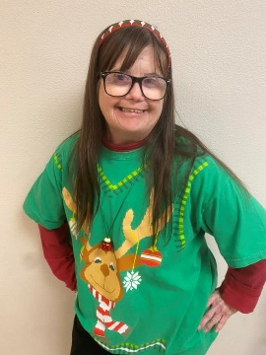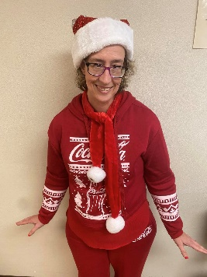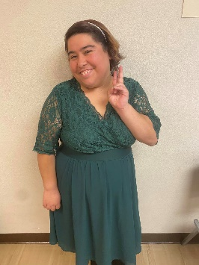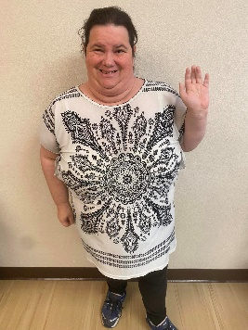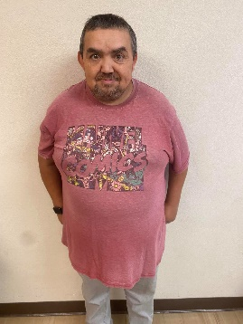

Chair Vice Chair Secretary Treasurer Sergeant of Arms

**Our mission is to help start and support local chapters.**

We will learn, inform, discover, and keep lines of communication open between people who make decisions that

impact the lives of people with developmental disabilities.



**SAC6 is the VMRC Consumer Advocate!**

The Consumer Advocate job is to help with the following:

* Ask people what services they need.
* Help people to find answers to their questions or problems.
* Let VMRC know about issues and problems.
* Work together to fix issues and problems.

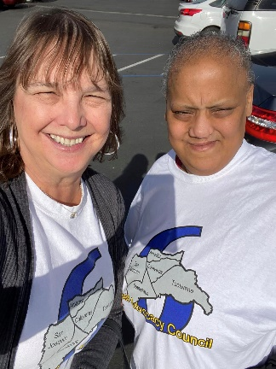

Lisa U. SAC6 Consultant and Dena #2 from SCDD North Valley Hills Office gave an Emergency Preparedness presentation to Central Valley Adult Day Care in Modesto. Each person received a backpack from the American Red Cross with important information and supplies. It is important to BE PREPARED!

******************************************************************************

Lisa, Jessica, and Crystal attended the Annual VMRC Board Retreat 2023 in Lodi.

November 2023 Stanislaus Area meeting. This was our first Area meeting back in person in Stanislaus County since COVID 19! We had a good turnout. Tony Anderson was in the house to give an update on VMRC! This area meeting topic was on Person Centered Planning!

Lots of great information!

**\*\*\*\*\*\*\*\*\*\*\*\*\*\*\*\*\*\*\*\*\*\*\*\*\*\*\*\*\*\*\*\*\*\*\*\*\*\*\*\*\*\*\*\*\*\*\*\*\*\*\*\*\*\*\*\*\*\***

# Up Coming Events- Mark Your calendars

# Shape Description automatically generated with low confidence Save the DATE CHOICES April 12, 2024.

# Supported Life InstituteSupported Life Logo

# A picture containing text Description automatically generatedStatewide Self Advocacy Conference is May 17 -18, 2024

# VMRC Transition Fairs- check [www.vmrc.net](http://www.vmrc.net) for dates

# 

**Farewell to Tony Anderson**

My name is **Minette Oliver**- I am the SAC6 **Vicechair person**. I represent Person Centered Services (PCS) in Stockton. On January 13, 2024, I attended Tony Anderson’s Goodbye Party in Stockton. SAC6 gave Tony a Certificate of Appreciation for his 7 years at VMRC. It was so much fun dressing up! I will definitely miss Tony and I am grateful for all his hard work he did while at VMRC.

# ***************************************************************************Two women smiling at the camera Description automatically generatedA group of women smiling for a selfie Description automatically generatedA group of women in a car Description automatically generated

# Hi everyone, my name is Lisa U., I am a consultant for SAC6. I would like to share that one great thing about being an advocate is making great friends along the way that feel like family!

# Make sure people always know we are here to help

# SAC 6 is YOUR VMRC Consumer Advocates!

**WANT a SAC6 Member to come and speak to your group??**

**JUST CALL US!**

Check us out on Facebook; SAC6 or on VMRC’s website [www.vmrc.net/sac6](http://www.vmrc.net/sac6)

Phone: 1-209-955-3306



# WANT TO BE IN AN UPCOMING CHATTER?

# CONTACT US!!

This Chatter SAC6 letter has been brought to you by our members:

Technical support by SCDD North Valley Hills

