SAC6 CHATTER Letter

August 2024

**2024 Self Advocacy Council 6 Team!**

**Our mission is to help start and support local chapters.**

Lisa U. and Crystal E. gave a session on Preparing for your IPP.

Catrina C. and Minette O. gave a presentation on Being an effective Board member.

Dena Pfiefer Sac6 Chairperson gave a session on her life story growing up with Down Syndrome.

Minette Oliver presentation was on her life story overcoming obstacles.

This year Supported Life Conference was great! So many Advocates form our Reginal Center attended!

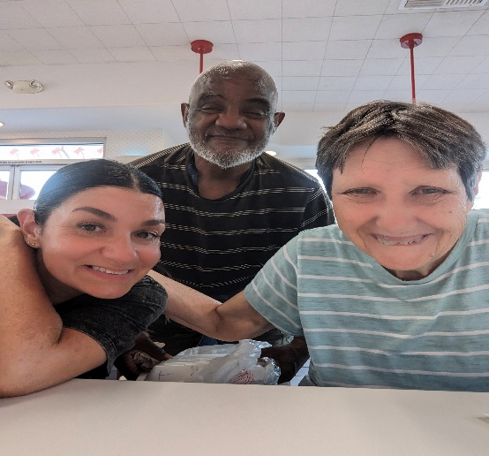

I was able to attend the 2024 statewide self-advocacy conference in Sacramento this year with my peer and facilitator. I was so happy to get a room to myself and have a few days away from home.

The session I enjoy the most was by Noe Dueñas. He shared a lot of good information and I liked that he handed out little buddies that we got to adopt out by sharing a little something about ourselves at the end of his session.

I also had fun swimming on Friday night and listening to the karaoke. I have shared with many of my peers that they can go too and get their trip paid for if they mention it to their case manager to have it put in their IPP.  I would like to thank VMRC for paying for me to attend and I look forward to going again next year. - Jessie Kennedy

Hello, my name is Lisa utsey. i wanted to share that on may 14, 2024, was kidz day! we worked with the salvation army to sell kids papers for a dollar. This is a great opportunity to give back to the kids in our community.

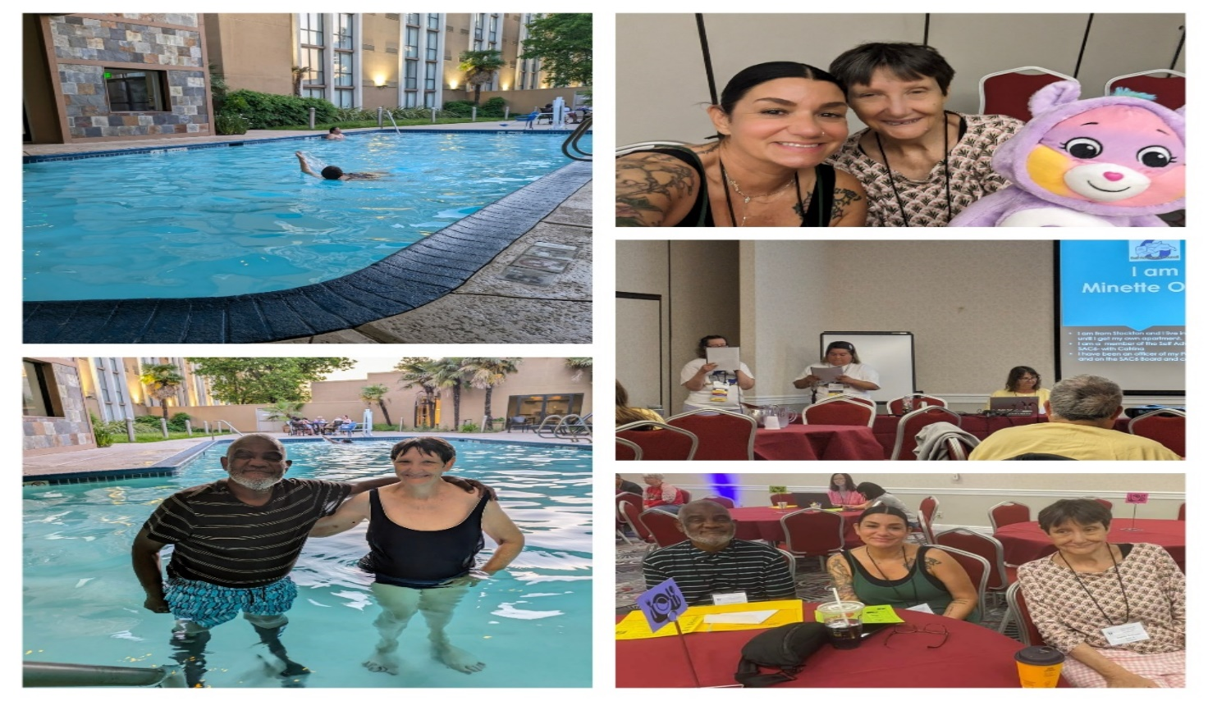

My name is Juanita Williams, and I attended the 2024 statewide self-advocacy conference in Sacramento with my Sac 6 friends and My facilitator. My favorite part of the conference was “ALL OF IT!” I love being on a little vacation.

The karaoke on Friday night was so good, swimming at the hotel pool was so much fun, I saw the sunset and the water was warm. My favorite session was “How to be an effective board member” with the keynote speakers from Sac-6. They shared a lot of good information, and they are all my friends. I also enjoy the Micro Fair where I purchased a conference t-shirt, a Care Bear, and a new bag with beautiful artwork on it, that I carry to program every day. I want to thank VMRC for paying for me to attend. I am looking forward to going again next year. If you too would like to attend a conference, make sure you speak to your case manager and get it in writing in your IPP.

Dena#2 and I went to Central Valley Adult Care Day program in Modesto. We shared information about Sac6 and how they can start their own self advocacy group! I was able to see some of my old friends and I always enjoy hanging out with my friend Dena!

My name is Catrina Castro, this was my second year attending the Supported Life Conference in May 2024. I had so much fun meeting new advocates, seeing my friends and I even sold my pens that my mom and me make together! I completely sold out so that was great! I hope to be back at the conference next year!

Hello everyone, my name is Crystal.

I wanted to share that i attended the Grassroots day in Sacramento with my fellow advocates Lisa and Catrina. we were able to talk to our local legislative leaders and tell them about our services and why it is so important to us that we get quality services.

On June 6th Sac6 had a Friday Zoom Chat and the Topic was presented by -Sherri Douglas from the Chico area who will talked about the Healthy U Series. Sherri shared lots of receipts and helpful tips on how we can eat healthier on a budget.

Flavored waters

Try any of the following fruits or herbs for flavoring water and adding some extra nutrition:

• Apples

• Basil

• Blackberries

• Blueberries

• Cantaloupe

• Cinnamon sticks

• Cucumber

• Ginger root (fresh)

• Grapes

• Grapefruit

• Jalapeño

• Kiwi

• Lemon

• Lime

• Mango

• Mint

• Orange

• Papaya

• Peach Raspberries

• Strawberries

• Watermelon

**\*\*\*\*\*\*\*\*\*\*\*\*\*\*\*\*\*\*\*\*\*\*\*\*\*\*\*\*\*\*\*\*\*\*\*\*\*\*\*\*\*\*\*\*\*\*\*\*\*\*\*\*\*\*\*\*\*\***

# Up Coming Events- Mark Your calendars

# Shape Description automatically generated with low confidence Save the DATE CHOICES April 2025.

# Supported Life InstituteSupported Life Logo

# Statewide Self Advocacy Conference May 2025

# 

# SAC 6 is YOUR VMRC Consumer Advocates!

**WANT a SAC6 Member to come and speak to your group??**

**JUST CALL US!**

Check us out on Facebook; SAC6 or on VMRC’s website [www.vmrc.net/sac6](http://www.vmrc.net/sac6)

Phone: 1-209-955-3306



# WANT TO BE IN AN UPCOMING CHATTER?

# CONTACT US!!

This Chatter SAC6 letter has been brought to you by our members:

Technical support by SCDD North Valley Hills

**SAC6 is the VMRC Consumer Advocate!**

The Consumer Advocate job is to help with the following:

* Ask people what services they need.
* Help people to find answers to their questions or problems.
* Let VMRC know about issues and problems.
* Work together to fix issues and problems.